 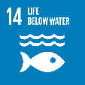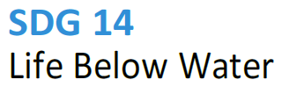

**14.5 Maintaining a local ecosystem**

**SDG 14 – Indicator 14.5.4 - Collaboration for shared aquatic ecosystems**

UNSRI Collaborates with Local Communities in Maintaining Aquatic Ecosystems

An aquatic ecosystem is an environment dominated by water and inhabited by a variety of living organisms. Protecting ecosystems is a shared responsibility, including by universities. Universitas Sriwijaya (UNSRI) is one of the higher education institutions located in South Sumatra. In an effort to support the sustainability of aquatic ecosystems, the UNSRI Community Service Team carried out an outreach program in collaboration with local communities and other universities (North Sumatra University). This activity was aimed at raising awareness among the local community, especially around the campus area, to protect the aquatic ecosystem, particularly in the region surrounding the Musi River in South Sumatra Province.

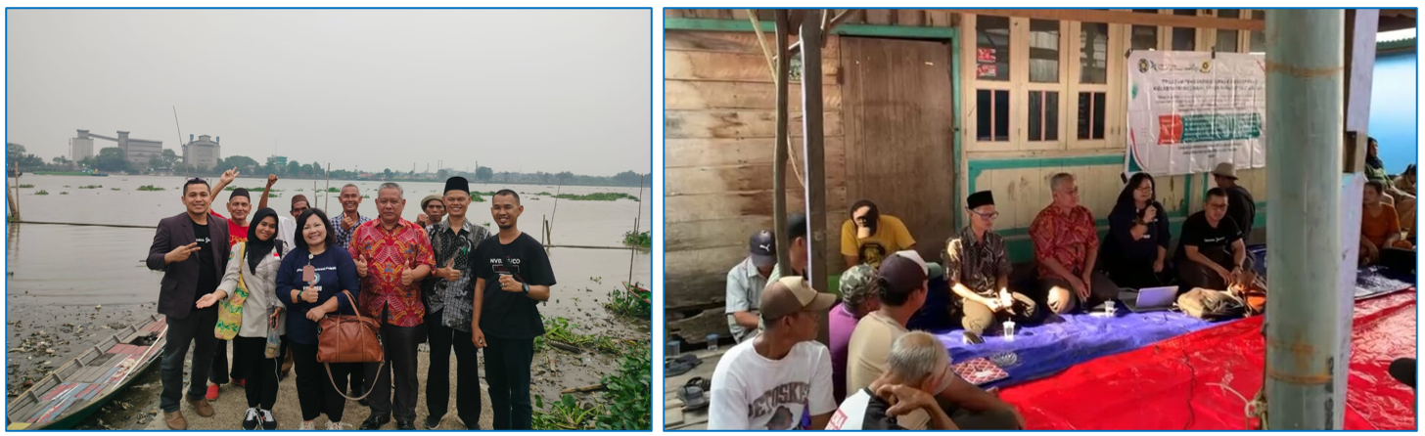

Link:

<https://www.kabarsriwijaya.com/2023/11/19/kolaborasi-usu-dan-unsri-tingkatkan-kesadaran-tata-kelola-air/>