 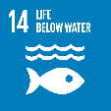

**14.3 Supporting aquatic ecosystems through action**

**SDG 14 – Indicator 14.3.2 - Food from aquatic ecosystems (policies)**

UNSRI Plays a Role in Increasing Fish Consumption

Universitas Sriwijaya (UNSRI) is one of the universities located in South Sumatra. UNSRI has a Department of Fisheries which is located in the Faculty of Agriculture. Several activities have been carried out by the Department of Fisheries in an effort to preserve fish. This supports South Sumatra in increasing fish consumption because fish is the second food after rice, especially in the South Sumatra region. To support the source of fish raw materials, UNSRI has made Embung which is one of the aquatic ecosystems as a place for fish farming on campus. The cultivated fish will then be consumed on campus or sold to the wider community. With the increase in fish consumption, it is expected to fulfil the need for protein in the body.

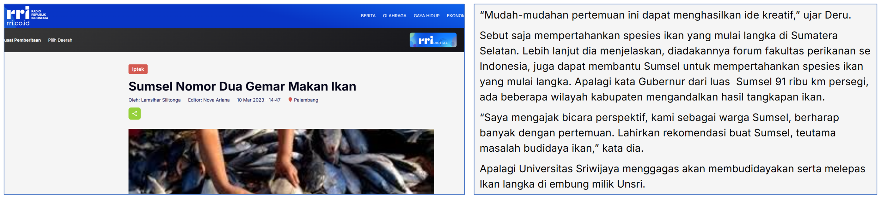

Link:

<https://rri.co.id/index.php/iptek/183621/sumsel-nomor-dua-gemar-makan-ikan>